**LAB # 01**



**Circuits and Systems Lab**

Submitted by: **Maaz Habib**

Registration No. :**20pwcse1952**

Class Section:

“On my honor, as student of University of Engineering and Technology, I have neither given nor received unauthorized assistance on this academic work.”

Submitted to:

**Engr. Fiaz ullah**

Month Day, Year (April,27, 2021)

Department of Computer Systems Engineering

University of Engineering and Technology, Peshawar

**Cathode ray oscilloscope (CRO)**

The **cathode ray oscilloscope** (**CRO**) is a type of electrical instrument which is used for showing the measurement and analysis of waveforms and others electronic and electrical phenomenon.

**OBJECTIVE:**

To learn how to operate a cathode-ray oscilloscope.

**APPARATUS:**

Cathode-ray oscilloscope,

Multimeter,

*Oscillator.*

**INTRODUCTION:**

The cathode-ray oscilloscope (CRO) is a common laboratory instrument that provides accurate time and aplitude measurements of voltage signals over a wide range of frequencies. Its reliability, stability, and ease of operation make it suitable as a general purpose laboratory instrument. The heart of the CRO is a cathode-ray tube shown schematically in Fig. 1.

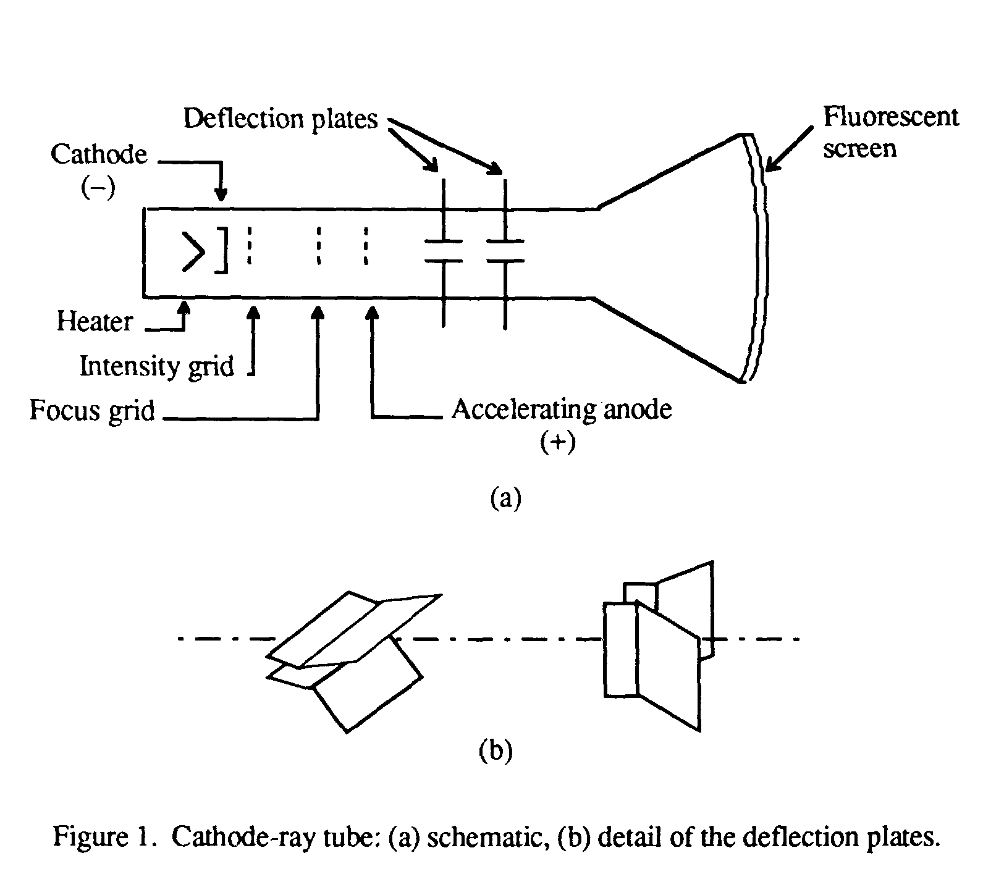

The cathode ray is a beam of electrons which are emitted by the heated cathode (negative electrode) and accelerated toward the fluorescent screen. The assembly of the cathode, intensity grid, focus grid, and accelerating anode (positive electrode) is called an *electron gun*. Its purpose is to generate the electron beam and control its intensity and focus. Between the electron gun and the fluorescent screen are two pair of metal plates - one oriented to provide horizontal deflection of the beam and one pair oriented ot give vertical deflection to the beam. These plates are thus referred to as the *horizontal* and *vertical deflection plates*. The combination of these two deflections allows the beam to reach any portion of the fluorescent screen. Wherever the electron beam hits the screen, the phosphor is excited and light is emitted from that point. This coversion of electron energy into light allows us to write with points or lines of light on an otherwise darkened screen.

In the most common use of the oscilloscope the signal to be studied is first amplified and then applied to the vertical (deflection) plates to deflect the beam vertically and at the same time a voltage that increases linearly with time is applied to the horizontal (deflection) plates thus causing the beam to be deflected horizontally at a uniform (constant> rate. The signal applied to the verical plates is thus displayed on the screen as a function of time. The horizontal axis serves as a uniform time scale.

The linear deflection or sweep of the beam horizontally is accomplished by use of a *sweep generator* that is incorporated in the oscilloscope circuitry. The voltage output of such a generator is that of a sawtooth wave as shown in Fig. 2. Application of one cycle of this voltage difference, which increases linearly with time, to the horizontal plates causes the beam to be deflected linearly with time across the tube face. When the voltage suddenly falls to zero, as at points (a) (b) (c), etc...., the end of each sweep - the beam flies back to its initial position. The horizontal deflection of the beam is repeated periodically, the frequency of this periodicity is adjustable by external controls.

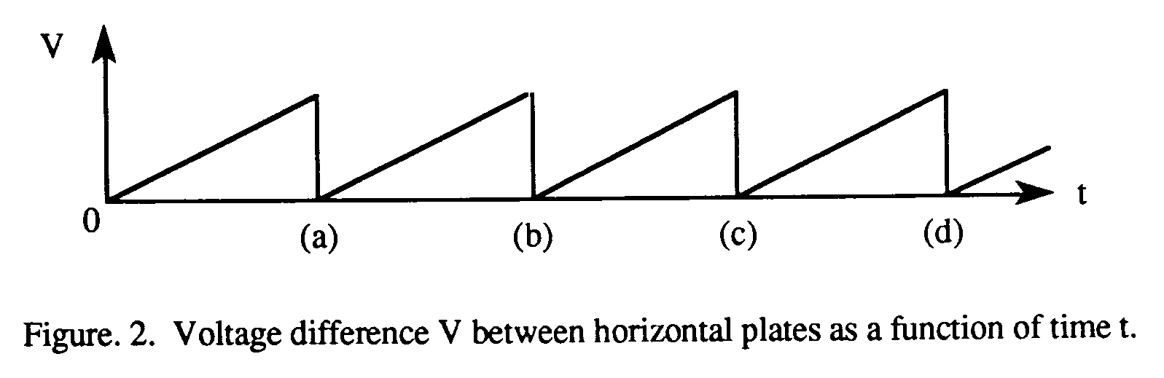

To obtain steady traces on the tube face, an internal number of cycles of the unknown signal that is applied to the vertical plates must be associated with each cycle of the sweep generator. Thus, with such a matching of synchronization of the two deflections, the pattern on the tube face repeats itself and hence appears to remain stationary. The persistance of vision in the human eye and of the glow of the fluorescent screen aids in producing a stationary pattern. In addition, the electron beam is cut off (blanked) during flyback so that the retrace sweep is not observed.

**CRO Operation:**  A simplified block diagram of a typical oscilloscope is shown in Fig. 3. In general, the instrument is operated in the following manner. The signal to be displayed is amplified by the vertical amplifier and applied to the verical deflection plates of the CRT. A portion of the signal in the vertical amplifier is applied to the **sweep trigger** as a triggering signal. The sweep trigger then generates a pulse coincident with a selected point in the cycle of the triggering signal. This pulse turns on the sweep generator, initiating the sawtooth wave form. The sawtooth wave is amplified by the horizontal amplifier and applied to the horizontal deflection plates. Usually, additional provisions signal are made for appliying an external triggering signal or utilizing the 60 Hz line for triggering. Also the sweep generator may be bypassed and an external signal applied directly to the horizontal amplifier.

**CONNECTIONS FOR THE OSCILLOSCOPE**

Vertical Input:  A pair of jacks for connecting the signal under study to the Y (or vertical) amplifier. The lower jack is grounded to the case.

Horizontal Input:  A pair of jacks for connecting an external signal to the horizontal amplifier. The lower terminal is graounted to the case of the oscilloscope.

External Tigger Input:  Input connector for external trigger signal.

Cal. Out:  Provides amplitude calibrated square waves of 25 and 500 millivolts for use in calibrating the gain of the amplifiers.

Accuracy of the vertical deflection is + 3%. Sensitivity is variable.

Horizontal sweep should be accurate to within 3%. Range of sweep is variable.

**Operating Instructions:**

Before plugging the oscilloscope into a wall receptacle, set the controls as follows:

(a) Power switch at off  
          (b) Intensity fully counter clockwise  
          (c) Vertical centering in the center of range  
          (d) Horizontal centering in the center of range  
          (e) Vertical at 0.2  
          (f) Sweep times 1

Plug line cord into a standard ac wall recepticle (nominally 118 V). Turn power on. Do not advance the Intensity Control.

Allow the scope to warm up for approximately two minutes, then turn the Intensity Control until the beam is visible on the screen.

**Observation:**

|  |  |  |  |  |  |
| --- | --- | --- | --- | --- | --- |
| Serial Number | Amplitude (volts) | Frequency (Hz) | Time Period (s) | Frequency Calculated (Hz) | Error (%) |
| 1. | 2 | 1 | 1 | 1 | 0% |
| 2. | 0.5 | 2.5 | 0.4 | 2.5 | 0% |
| 3. | 1.5 | 3 | 0.3 | 3.3 | 9% |
| 4. | 1 | 2 | 0.5 | 2 | 0% |
| 5. | 10 | 2 | 0.5 | 2 | 0% |
| 6. | 0.7 | 2 | 0.5 | 2 | 0% |
| 7. | 0,7 | 2.5 | 0.4 | 2.5 | 0% |
| 8. | 0.5 | 1 | 0.8 | 1.25 | 0% |
| 9. | 10 | 2 | 0.5 | 2 | 0% |
| 10. | 30 | 5 | 2.0 | 5 | 0% |

**Digital multimeter**

A **digital multimeter** is a test tool used to measure two or more electrical values—principally voltage (volts), current (amps) and resistance (ohms). It is a standard diagnostic tool for technicians in the electrical/electronic industries.

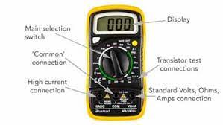

# Function Generator:

A function generator is usually a piece of electronic test equipment used to generate different types of electrical waveforms over a wide range of frequencies. Some of the waveforms produced by function generator are sinusoidal(sine), square, triangle, Sawtooth.

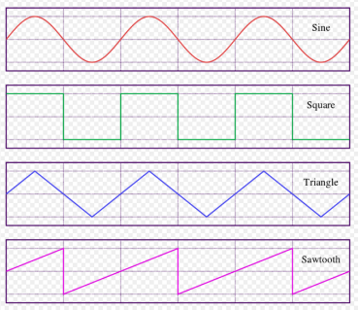

Function generators are used in the development, test and repair of electronic equipment. For example, they may be used as a signal source to test amplifiers or to introduce an error signal into a control loop. Function generators are primarily used for working with analog circuits, related pulse generators are primarily used for working with digital circuits.

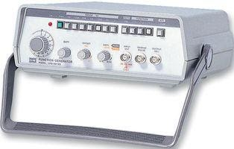

# Power Supply:

A power supply is an electrical device that supplies energy to the circuit. The function of the power supply is to convert one form of electrical energy into another form. Power supplies can give us varying voltages and currents according to our need.

Power supply has single power input and have multiple power outputs. Power supplies are made in different sizes and capacities. In some devices the power supplies are embedded inside the device while in some machines the power supplies are external.

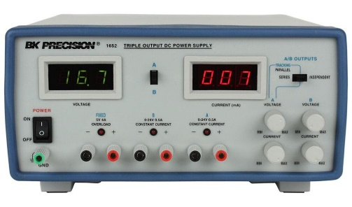

# Digital Multimeter:

A digital multimeter (DMM) is a test tool used to measure two or more electrical values—principally voltage (volts), current (amps) and resistance (ohms). It is a standard diagnostic tool in the electrical/electronic industries.

Digital multimeters long ago replaced needle-based analog meters due to their ability to measure with greater accuracy, reliability and increased impedance.

Digital multimeters combine the testing capabilities of single-task meters—the voltmeter (for measuring volts), ammeter (amps) and ohmmeter (ohms). Often they include a number of additional specialized features or advanced options. Technicians with specific needs, therefore, can seek out a model targeted for particular tasks.

The face of a digital multimeter typically includes four components:

1. Display
2. Buttons
3. Dial (or rotary switch)
4. Input jacks

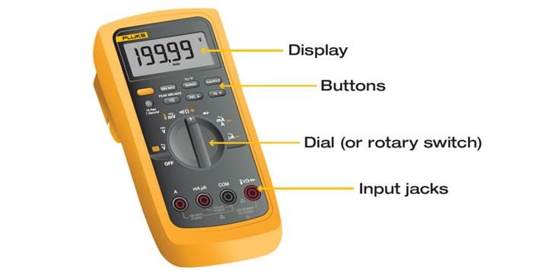

The **Display** shows the digital reading on the screen. The reading is shown on the screen with digits.

The **Buttons** are used for different features in multimeter.

The **Dial** is used to set the range before taking the reading. It is good to set the dial at a range closer to the actual reading in order to get the accurate readings. Before taking the readings of the voltage it is a precaution to set the dial at minimum before taking the reading otherwise the device could damage.

The **Input jacks** are used to insert the knobs into the device in order to connect the apparatus for measurement. Different input jacks are used for measuring voltage and currents.

# Experiment :

To find the voltage and current of power supply using Digital Multimeter.

# Procedure:

1. Connect the knobs to the power supply and note the reading given on the power supply.
2. Connect the multimeter with the knobs, negative with the negative one and positive with the positive one.
3. Set the multimeter at the minimum to measure the voltage and then turn ON the power supply.
4. Note the readings from the screen of the multimeter.
5. Find the current using the formula =vr .
6. Compare the readings taken from the multimeter with the actual reading of the power and find error.

# Observation:

|  |  |  |  |  |  |  |
| --- | --- | --- | --- | --- | --- | --- |
|  | **Voltage** | | | **Current** | | |
| **Serial Numbers** | **Power Supply  (V)** | **Digital Multimeter (V)** | **Error (%)** | **Power Supply  (I)** | **Digital Multimeter (I)** | **Error (%)** |
| 1. | 5 | 5 | 0% | 5 | 0.5 | 0% |
| 2. | 7 | 7 | 0% | 10 | 1.0 | 0% |
| 3. | 9.2 | 9.2 | 0% | 20 | 2.0 | 0% |
| 5. | 8 | 8 | 0% | 30 | 3.0 | 0% |
| 6. | 1.5 | 1.5 | 0% | 4 | 4.0 | 0% |
| 7. | 9 | 9 | 0% | 3 | 3.0 | 0% |
| 8. | 10 | 10 | 0% | 25 | 2.6 | 0% |
| 9. | 4 | 4 | 0% | 15 | 1.5 | 0% |
| 10. | 12 | 12 | 0% | 2 | 2.0 | 0% |